A [Bipartite Graph](http://en.wikipedia.org/wiki/Bipartite_graph) is a graph whose vertices can be divided into two independent sets, U and V such that every edge (u, v) either connects a vertex from U to V or a vertex from V to U. In other words, for every edge (u, v), either u belongs to U and v to V, or u belongs to V and v to U. We can also say that there is no edge that connects vertices of same set.

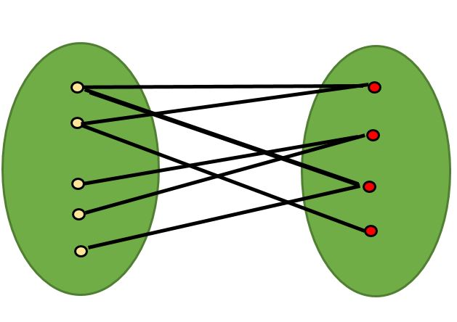

**A bipartite graph is possible if the graph coloring is possible using two colors such that vertices in a set are colored with the same color.**

Note that it is possible to color a cycle graph with even cycle using two colors.

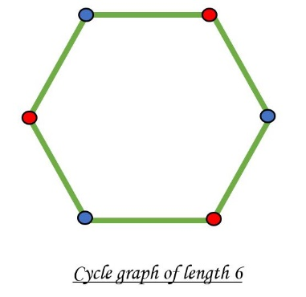

It is **NOT possible to colour a cycle graph with odd cycle using two colours.**

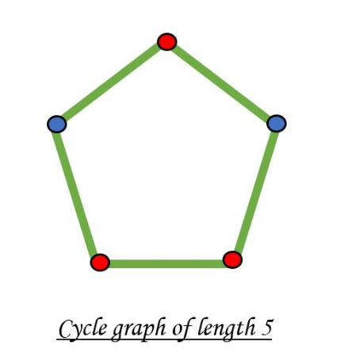

In a Bipartite graph, **adjacent nodes can NOT have the same colour.**

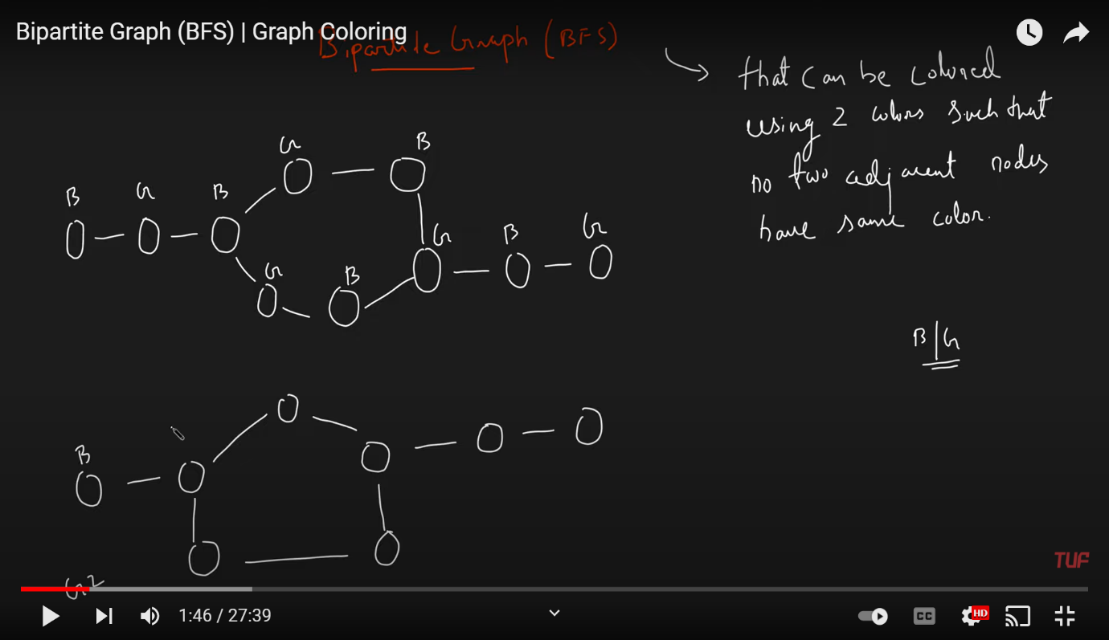

VVIMP STATEMENT:

**If a graph has odd length cycle, then its never Bipartite.**

**If a graph does NOT have an odd length cycle, then surely Bipartite.**